**Test Case** **0020**

**System:** VirtuCardsClient & VirtuCardsHost

**Description:** Tests that the cards each client has are represented on the common screen

**Severity:** 3

**Instructions**

**Test1**

1. Start VirtuCardClient application
2. Click the button labeled “Sign In”
3. Enter “virtucards01@gmail.com” into the text input labeled “Enter email…”
4. Enter “Testing1” into the text input labeled “Enter password…”
5. Press the button labeled “Login”
6. A window should appear saying “Login Success”
7. Press the OK button that appears on that window
8. Start a second VirtuCardHost application
9. Repeat steps 2-7, but use “virtucards02@gmail.com” as the email and use “Testing1” as the password.
10. Start VirtuCardHost application
11. Repeat steps 2-7 but on the VirtuCardHost application
12. The checkbox “Allow Host to Join” should be checked on the host
13. Select the “TestGame” option from the game choices dropdown
14. Press the Create Game button
15. On both VirtuCardClient applications enter the 6-character room code found on the host’s screen into the field labeled “Enter Code…”
16. Press the Join Game button on both clients
17. Press the Start Game button on the host application

**Expected Result:** Each of the clients should have 0 cards, and the host should show both players on the upper part of the screen along with 0’s on top of their pile of cards.

**Upper left-hand side of the host screen**

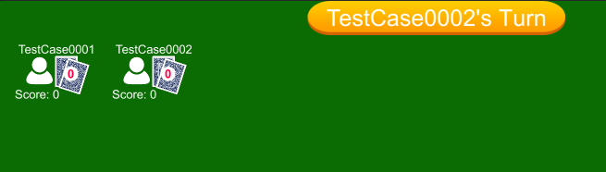

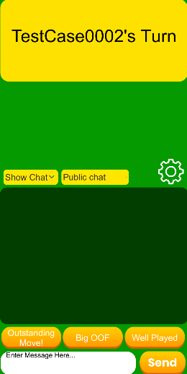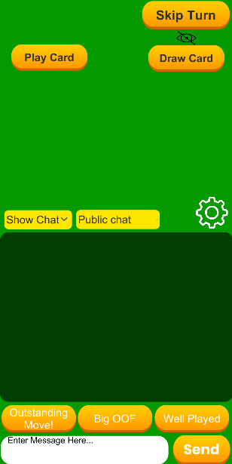 **Client 1’s Screen Client 2’s Screen**

**Test2**

1. Start VirtuCardClient application
2. Click the button labeled “Sign In”
3. Enter “virtucards01@gmail.com” into the text input labeled “Enter email…”
4. Enter “Testing1” into the text input labeled “Enter password…”
5. Press the button labeled “Login”
6. A window should appear saying “Login Success”
7. Press the OK button that appears on that window
8. Start a second VirtuCardHost application
9. Repeat steps 2-7, but use “virtucards02@gmail.com” as the email and use “Testing1” as the password.
10. Start VirtuCardHost application
11. Repeat steps 2-7 but on the VirtuCardHost application
12. The checkbox “Allow Host to Join” should be checked on the host
13. Select the “TestGame” option from the game choices dropdown
14. Press the Create Game button
15. On both VirtuCardClient applications enter the 6-character room code found on the host’s screen into the field labeled “Enter Code…”
16. Press the Join Game button on both clients
17. Press the Start Game button on the host application
18. On the client who has the turn available, press the Draw Card button

**Expected Result:** The client that pressed the Draw Card button should have a 1 instead of a 0 on their pile of cards. The other should still remain at 0.

**Upper left-hand side of the host screen**

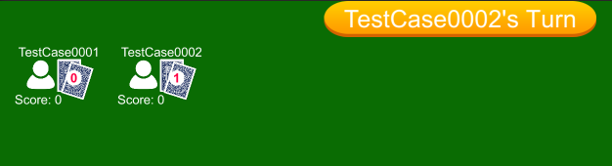

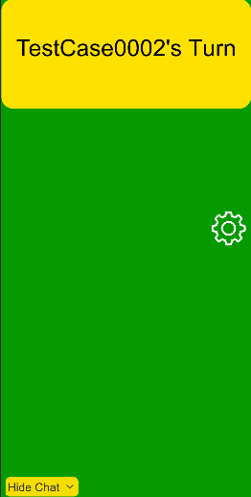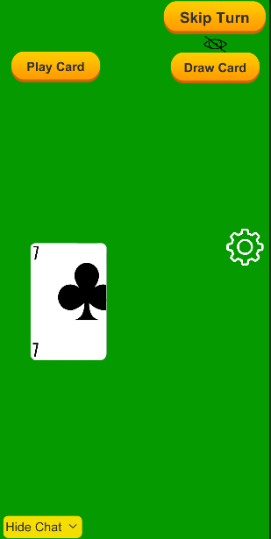 **Client 1’s Screen Client 2’s Screen**

**Test3**

1. Start VirtuCardClient application
2. Click the button labeled “Sign In”
3. Enter “virtucards01@gmail.com” into the text input labeled “Enter email…”
4. Enter “Testing1” into the text input labeled “Enter password…”
5. Press the button labeled “Login”
6. A window should appear saying “Login Success”
7. Press the OK button that appears on that window
8. Start a second VirtuCardHost application
9. Repeat steps 2-7, but use “virtucards02@gmail.com” as the email and use “Testing1” as the password.
10. Start VirtuCardHost application
11. Repeat steps 2-7 but on the VirtuCardHost application
12. The checkbox “Allow Host to Join” should be checked on the host
13. Select the “TestGame” option from the game choices dropdown
14. Press the Create Game button
15. On both VirtuCardClient applications enter the 6-character room code found on the host’s screen into the field labeled “Enter Code…”
16. Press the Join Game button on both clients
17. Press the Start Game button on the host application
18. On the client who has the turn available, press the Draw Card button
19. On that same client, press the Skip Turn button
20. On the second client, press the Draw Card button
21. On that same second client, press the Draw Card button again

**Expected Result:** The client that pressed the Draw Card button first should have a 1 on their pile of cards. The other should have the number 2.

**Upper left-hand side of the host screen**

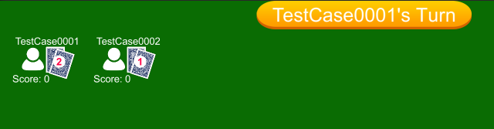

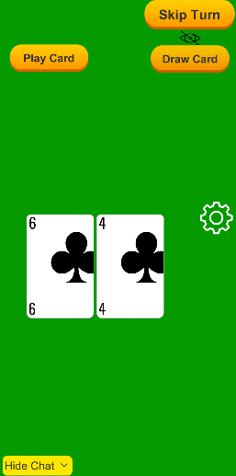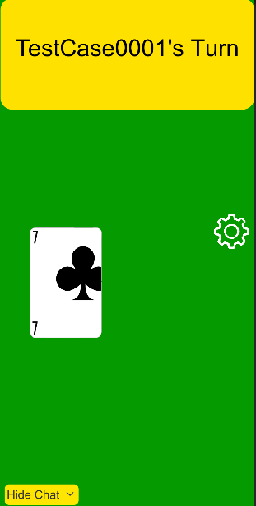 **Client 1’s Screen Client 2’s Screen**

**Test4**

1. Start VirtuCardClient application
2. Click the button labeled “Sign In”
3. Enter “virtucards01@gmail.com” into the text input labeled “Enter email…”
4. Enter “Testing1” into the text input labeled “Enter password…”
5. Press the button labeled “Login”
6. A window should appear saying “Login Success”
7. Press the OK button that appears on that window
8. Start a second VirtuCardHost application
9. Repeat steps 2-7, but use “virtucards02@gmail.com” as the email and use “Testing1” as the password.
10. Start VirtuCardHost application
11. Repeat steps 2-7 but on the VirtuCardHost application
12. The checkbox “Allow Host to Join” should be checked on the host
13. Select the “TestGame” option from the game choices dropdown
14. Press the Create Game button
15. On both VirtuCardClient applications enter the 6-character room code found on the host’s screen into the field labeled “Enter Code…”
16. Press the Join Game button on both clients
17. Press the Start Game button on the host application
18. On the client who has the turn available, press the Draw Card button
19. On that same client, press the Skip Turn button
20. On the second client, press the Draw Card button
21. On that same second client, press the Draw Card button again
22. On that same client again, press the Skip Turn button
23. On the first client, press the Play Card button

**Expected Result:** The client that pressed the Draw Card button first should have a 0 on their pile of cards. The other should have the number 2.

**Upper left-hand side of the host screen**

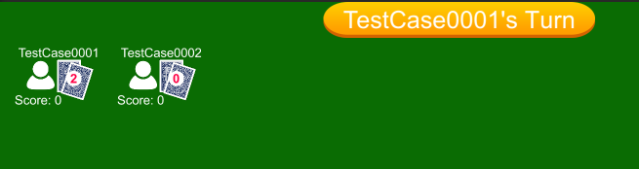

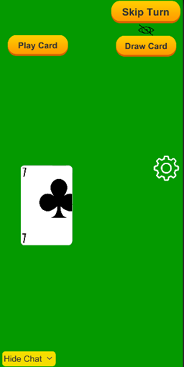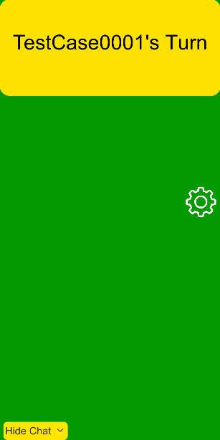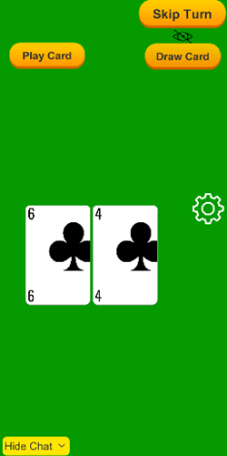 **Client 1’s Screen Client 2’s Screen (Before and After Playing the Card)**